**RS-232 Loopback Rev.0**

**Module description**

# Introduction

The RS-232 loopback is a tool for testing or sniffing an RS-232/TTL serial interface. It has a female (DTE/computer side) D-Sub (9 pins) connector, a male (DCE/modem side) D-Sub (9 pin) and a 2x5 box connector/pin header, which is configured for connecting the RS232 via a ribbon cable.

There are three feedbacks, that can be jumpered. The status of each feedback is indicated with a bi-color LED.

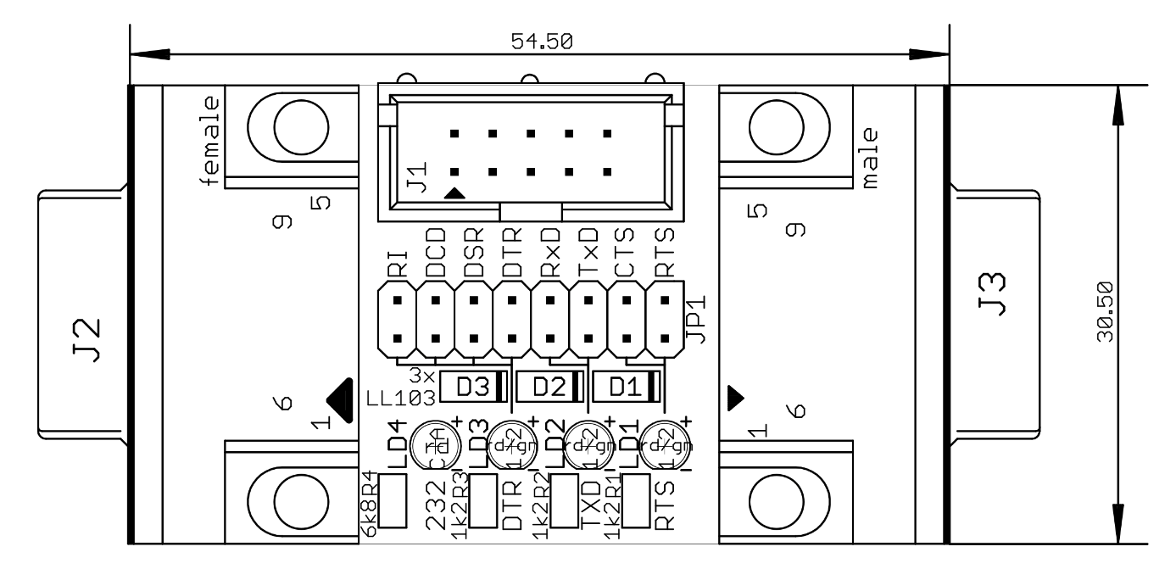

Figure 1: Dimensions of the RS-232 Loopback

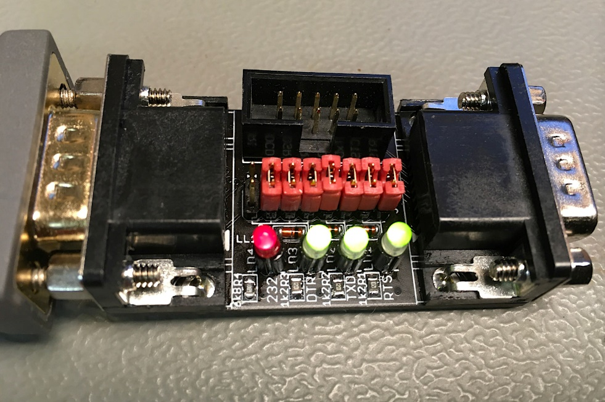

Figure 2: Connected RS-232 loopback

# Feedbacks /Jumper/Indicators

## Jumper J1

|  |  |  |  |
| --- | --- | --- | --- |
| Feedback | Signals | Jumper JP1 | LED |
| RTS | RTS CTS | 1-2 3-4 | LD1 |
| TXD | TxD RxD | 5-6 7-8 | LD2 |
| DTR | DTR DSR DCD RI | 9-10 11-12 13-14 15-16 | LD3 |

## LEDs

### RS-232

RxD, TxD: The voltage level for a logic “0” (aka “space”) is +3V to +15V, for logic “1” (aka “mark”) it is -3V to -15V. voltages between -3V to +3V are an “illegal state”. For the handshake signals (RTS, CTS, DTR, DSR, DCD and RI) active is a positive +3V to +15V, while not active is negative -3V to -15V).

The RTS and DTR LEDs are **red while active** and **green while not active**. When idle, the TxD LED LD2 is green (indicating a negative voltage level) and blinking while data is being transferred.

### TTL

The RTS and DTR LEDs are **off while active** (LOW) and **red while not active** (HIGH). These signals are active low in TTL level). While idle, the TxD LED (LD2) is on.

### Level Indicator

There is a 4th LED (LD4) indicating the level: RS-232 (on), TTL (off).

# Connectors

## J1 (Box connector to DTE/Computer)

This is a **2x5 pin box connector**. It is configured to fit a ribbon cable to a 2.54mm pitch pin header on a motherboard of a computer or to connect a D-Sub connector

|  |  |  |  |
| --- | --- | --- | --- |
| Signal | Pin | Pin | Signal |
| DCD | 1 | 2 | DSR |
| RxD | 3 | 4 | RTS |
| TxD | 5 | 6 | CTS |
| DTR | 7 | 8 | RI |
| GND | 9 | 10 | - |

## J2 (to DTE/Computer)

This is a **female 9 pin D-Sub connector**. It has the standard pinout of a modem side and fits directly or via a modem cable into the serial port of a computer.

|  |  |  |  |
| --- | --- | --- | --- |
| Signal | Pin | Pin | Signal |
| DCD | 1 | 6 | DSR |
| RxD | 2 | 7 | RTS |
| TxD | 3 | 8 | CTS |
| DTR | 4 | 9 | RI |
| GND | 5 |  |  |

## J3 (to DCE/modem)

This is a **male 9 pin D-Sub connector**. It has the standard pinout of the serial interface of a computer/DTE and fits directly or via a modem cable into the serial port of a modem/DCE.

|  |  |  |  |
| --- | --- | --- | --- |
| Signal | Pin | Pin | Signal |
| DSR | 6 | 1 | DCD |
| RTS | 7 | 2 | RxD |
| CTS | 8 | 3 | TxD |
| RI | 9 | 4 | DTR |
|  |  | 5 | GND |

# Revision History

## Rev. 0

* Prototype: fully functional